Hamza Salahuddin
24k-3065
Lab-07
Task-02
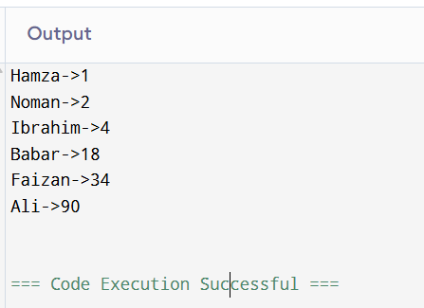
#include<iostream>
using namespace std;

class Participant{
public:
string name;
int time;
Participant(string n,int t){
name=n;
time=t;
}
};

void Merge(int arr[],int start,int mid,int end){
int temp[100];
int i=start;
int j=mid+1;
int k=0;
while(i<=mid && j<=end){
if(arr[i]<arr[j]){
temp[k]=arr[i];
i++;
k++;
}
else{
temp[k]=arr[j];
j++;
k++;
}
}
while(i<=mid){
temp[k]=arr[i];
i++;
k++;
}
while(j<=end){
temp[k]=arr[j];
j++;
k++;
}
for(int t=0;t<k;t++){
arr[start+t]=temp[t];
}

}

void Mergesort(int arr[],int start,int end){
if(start<end){
int mid=start+(end-start)/2;
Mergesort(arr,start,mid);
Mergesort(arr,mid+1,end);
Merge(arr,start,mid,end);
}
}

int main(){
Participant p1("Hamza",1);
Participant p2("Ibrahim",4);
Participant p3("Noman",2);
Participant p4("Ali",90);
Participant p5("Faizan",34);
Participant p6("Babar",18);
Participant pa[]={p1,p2,p3,p4,p5,p6};
int arr[]={p1.time,p2.time,p3.time,p4.time,p5.time,p6.time};
Mergesort(arr,0,5);

for(int i=0;i<6;i++){
for(int j=0;j<6;j++){
if(arr[i]==pa[j].time){
cout<<pa[j].name<<"->"<<arr[i]<<endl;
}
}
}
}
Task-03
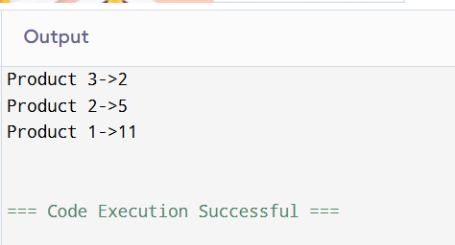
#include<iostream>
using namespace std;

class Product{
public:
string name;
int price;
bool availability;

Product(string n,int p,bool a){
name=n;
price=p;
availability=a;
}
};

int partition(int arr[],int low,int high){
int pivot=arr[high];
int i=low-1;
for(int j=low;j<high;j++){
if(arr[j]<pivot){
i++;
swap(arr[i],arr[j]);
}
}
i++;
swap(arr[i],arr[high]);
return i;
}

void Quicksort(int arr[],int low ,int high){
if(low<high){
int pivot=partition(arr,low,high);
Quicksort(arr,low,pivot-1);
Quicksort(arr,pivot+1,high);
}
}

int main(){
Product p1("Product 1",11,true);
Product p2("Product 2",5,true);
Product p3("Product 3",2,true);
Product p[]={p1,p2,p3};
int arr[]={p1.price,p2.price,p3.price};
Quicksort(arr,0,2);

for(int i=0;i<3;i++){
for(int j=0;j<3;j++){
if(arr[i]==p[j].price){
cout<<p[j].name<<"->"<<p[j].price<<endl;
}
}
}
}

